Prerequisites
The following are prerequisites for the successful completion of this procedure:
- Approved change within BMC Helix with appropriate notes attached to the change.
- Attach Data TSM approval to the change.
- Engage business stakeholders at least one week before the change if they must perform pre-test.
- Attach dated Detail Design with new version information to Records Manager.
- Place the new setup file before the build starts; otherwise, arrange for it.
- Bring down the application tier before commencing the procedure.
- Perform database and infrastructure health checks

  - Perform full backup with copy_only of user and system databases on E:\backup
  - Check database status:

  - use master
  - go
  - select serverproperty ('servername') as [Instance Name],
  - name as [Database Name],state_desc as [Status] ,user_access_desc as [User Access Desc],
  - case is_auto_close_on
  - when 1 then 'ON'
  - when 0 then 'OFF'
  - end as [Auto Close]
from sys.databases
- Check the active connections on the target database:
- SELECT
- DB_NAME(dbid) as DBName, hostname,
- COUNT(dbid) as NumberOfConnections,
- loginame as LoginName
- FROM
- master..sysprocesses
- WHERE
- dbid > 0
- GROUP BY
- dbid, loginame,hostname
- go
- Check the SQL Server Error Log for application login failures:
- Check the Windows application event log.
- Determine storage, memory, and processor requirements for the new infrastructure. Allocate additional storage if needed.
- Identify infrastructure components within the database migration scope:
  - Compatibility level
  - Collation Level
  - Application related databases.
  - SQL Server Logins associated with affected databases.
  - Jobs and Maintenance Plans related to the database.
  - Server Objects used by logic within the affected database.
- Check the following stored procedures are present in the master database:
  - sp_help_revlogin_2000_to_2005 (Migration from SQL Server 2000 to 2005)
  - sp_help_revlogin (Migration from SQL Server 2005 and later)
  - sp_hexadecimal
- Identify fragmented indexes for rebuilding during migration.
- SELECT *
- INTO DBA_Maintenance.bcc.index_maintenance_requests
- FROM sys.dm_db_index_physical_stats (NULL, NULL, NULL , NULL, 'LIMITED')
WHERE avg_fragmentation_in_percent > 10 AND index_id > 0;
Actions
- In-place upgrade: Procedure #1
- Log in to the server using the bcc\database account.
- Complete prerequisites before proceeding.
- Stop the application.
- Stop database services for the old infrastructure.
- Run the SQL Server setup (new version) as administrator.
- In the left-hand navigation, click Installation, then select Upgrade from previous versions of SQL Server.
- Click Next
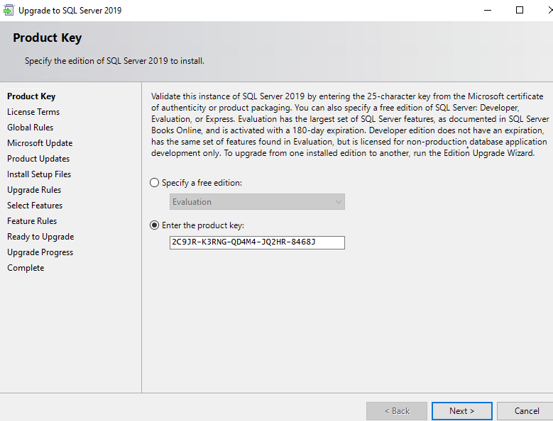
- Accept the license terms, then click Next.
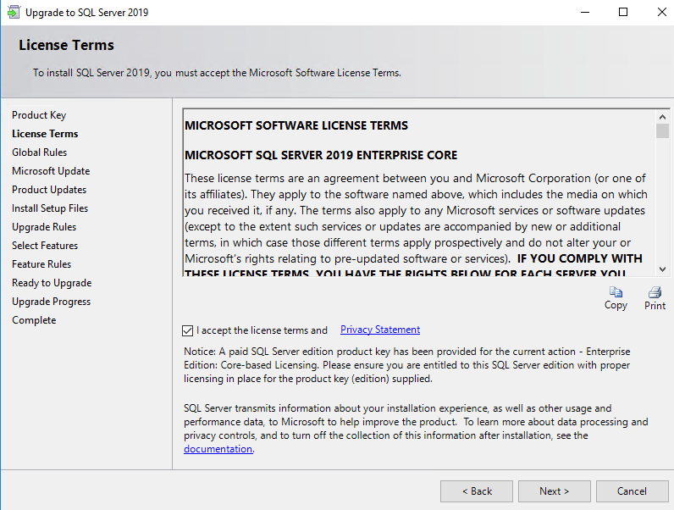
- Click next
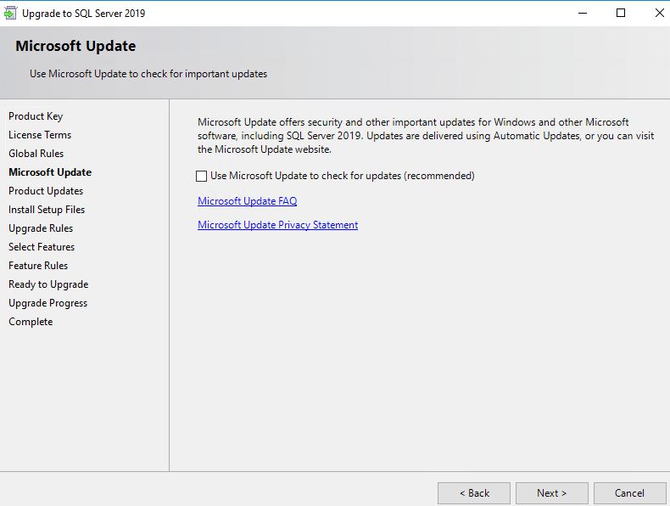
- Click Next on product updates.
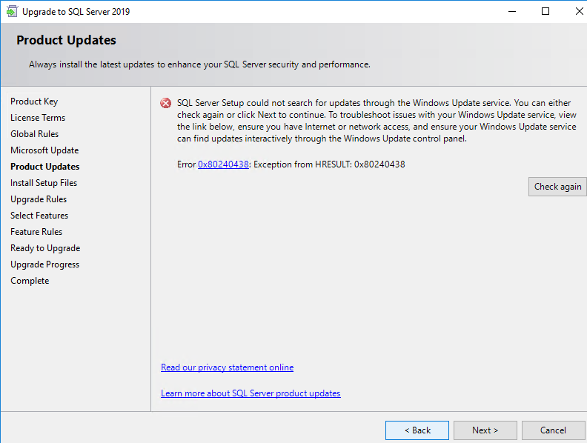
- Select instance to be upgraded,
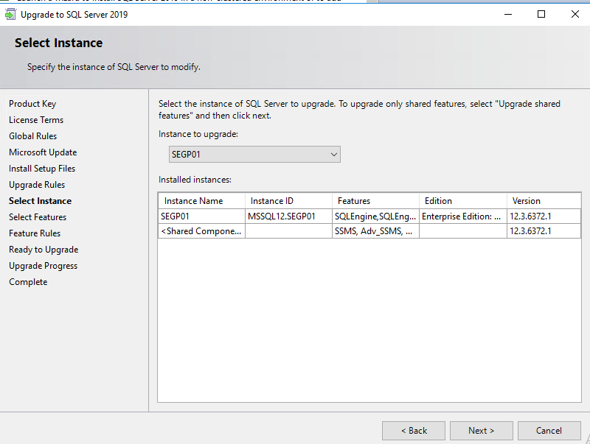
- Select all features
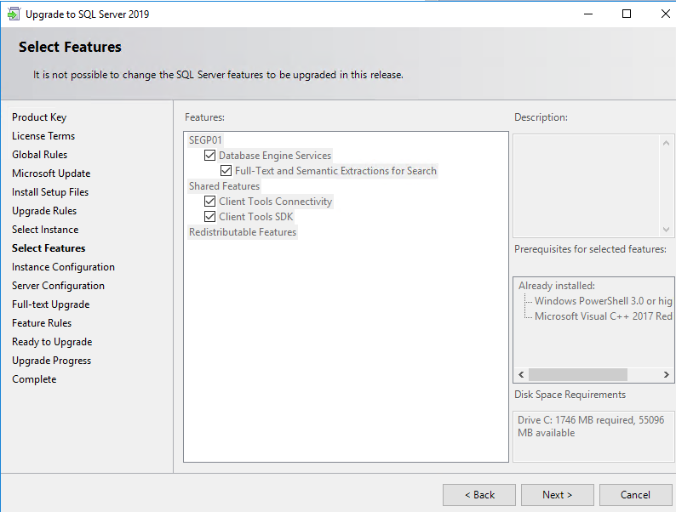
- Click next
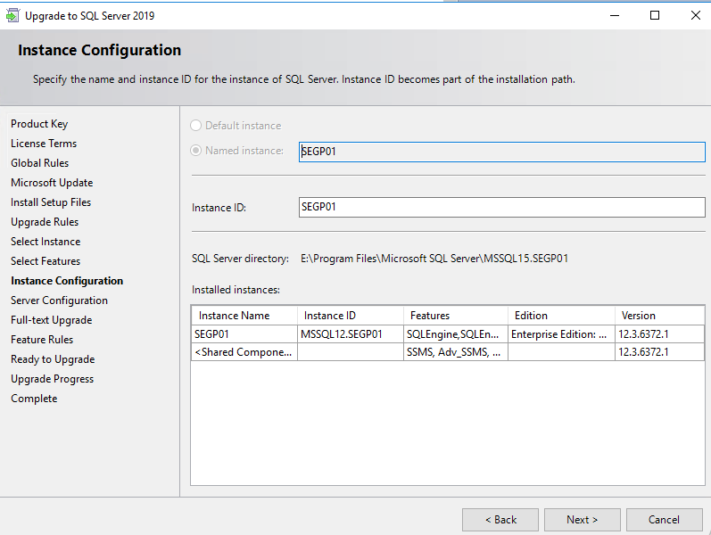
- Click next
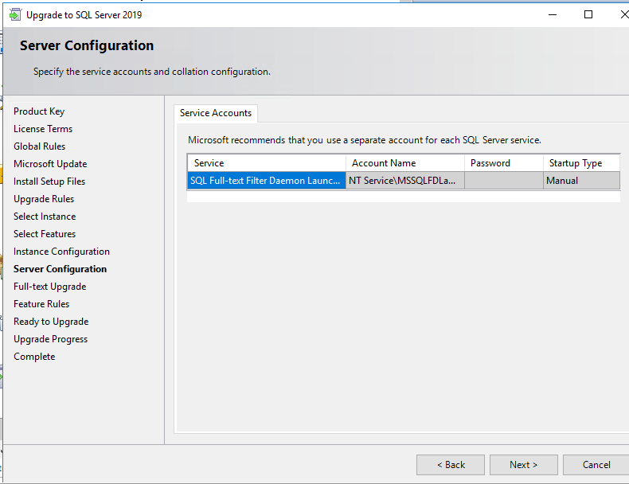
- On the Full-Text Search Upgrade Options page, specify the upgrade options for the databases
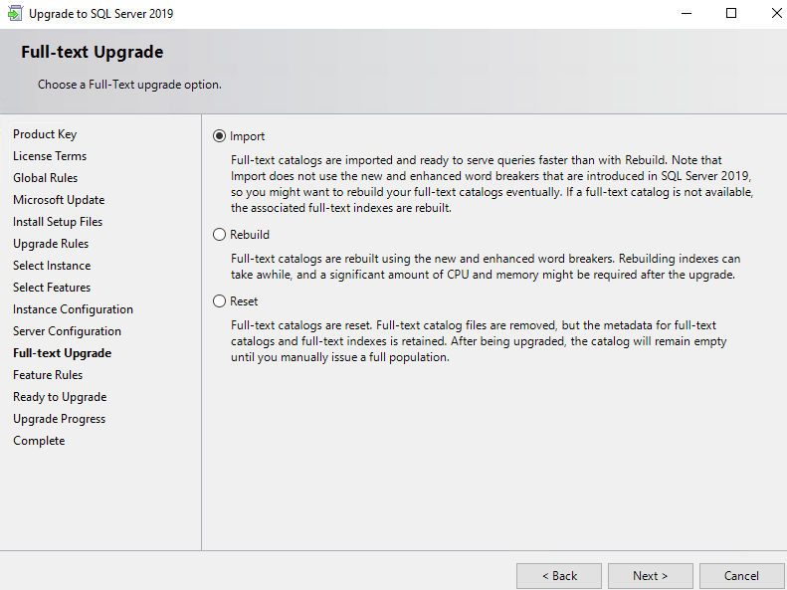
- The Feature Rules window advances automatically if all rules pass.
- The Ready to Upgrade page shows a tree view of installation options specified during Setup. Click Install.
- During installation, the progress page displays status to monitor installation as Setup continues.
- After installation, the Complete page provides a link to the summary log and other important notes. Click Close to finish the SQL Server installation.
- Reboot the server.
- After reboot, execute the following command to check the server version
- SELECT
- SERVERPROPERTY('ServerName') as [SQL Server Instance Name] ,
- SERVERPROPERTY('Edition') as Edition ,
- SERVERPROPERTY('ProductVersion') as Version,
SERVERPROPERTY('Productlevel') as [Product Level],
- In Place Upgrade : Procedure#2
- Log in to the server using the bcc\database account.
- Complete process prerequisites before proceeding.
- Ensure the application is stopped.
- Stop database services for the old infrastructure and set startup mode to manual.
- Install the new version to upgrade. Refer
- Perform post-installation and health checks on the new build.
- Reboot the server.
- Upgrade the new server with the latest SP or CU update if required.
- Reboot the server.
- Migrate the database from the old environment to the new environment.
- Migrate ports and perform health checks for the migrated database.
- Ensure the old environment's database services are stopped, as the same accounts are used for the new build.
- Request the application team to start the application and perform health checks.
- Restart the central job to update the database to the latest version.
- If successful, decommission the old environment after 7 days by uninstalling the old version.

